**ESS Job Document Information**

|  |  |
| --- | --- |
| **Title** | Oracle Reusable Components - ESS Job |
| **Version** | 1.0 |
| **Date** | 10.11.2020 |
| **Authors** | Subadurga J D |
| **User Story** |  |

**Document Review & Sign-off**

***Reviewers***

|  |  |  |  |  |
| --- | --- | --- | --- | --- |
| **SNO** | **Name** | **Comments Received** | **Approved** | **Date** |
| 1 | Subba Sivaji Muppuri Venkata | Description to each section and formatting |  | 13.11.2020 |
| 2 | Raghunath Narpala | Description to each section and formatting |  | 28.07.2021 |

***Revision History***

|  |  |  |  |
| --- | --- | --- | --- |
| **Version No.** | **Date** | **Author** | **Revision Description** |
| 1.0 | 10.11.2020 | Subadurga J D | First version |
| 1.1 | 28.07.2021 | Akshay Kumbhare |  |
| 1.2 |  |  |  |
| 1.3 |  |  |  |

**Other Related Documents**

| **Related Document** | **Comment** |
| --- | --- |
|  |  |
|  |  |
|  |  |
|  |  |
|  |  |
|  |  |

**CONTENT**

**1** **Overview of the Process** 3

**1.1** **Configuration** 3

**1.2** **Process Usage** 4

**1.3** **Demo Process** 5

**1.4** **Testing** 6

**1.4.1** **Testcases without Parameters: (Positive scenario)** 6

**1.4.2** **ESS Job-With Parameters List-Exceptional Handling: (Negative scenario)** 9

**1.5** **Sample Request and Response** 10

**1.5.1** **Profile Name: SubmitESSJobRequest** 10

**1.5.2** **Profile Name: SubmitESSJobRequestResponse** 11

**1.5.3** **Profile Name: getESSJobStatusRequest** 11

**1.5.4** **Profile Name: getESSJobStatusResponse** 11

### **Overview**

This document gives the overview of integration with Oracle via ESS jobs using Dell Boomi as Integration tool.

**Details on ESS (Enterprise Scheduler Service):**

An ESS Job may be considered as an equivalent to Concurrent Program of an EBS Application. However, in a Cloud Deployment model one is not allowed to run any custom programs/processes which makes changes to the application data. One may however copy the delivered ESS processes and make minor changes to it

### **Overview of the Process**

The process is designed to submit the ESS Job request to Oracle SaaS with input request parameters and get the status of submitted ESS job with dynamic and reusable component.

In general, From Dell boomi we submit the ESS job to oracle and then need to capture the response which is a unique job id to track the status of the submitted job at oracle SaaS. different set of status received from oracle SaaS to Dell Boomi like Wait, Hold, Running, Error, Warning, Completed, succeeded etc., and must repeat the status identification step till the job gets fail/complete.

All these steps have been arranged in this process such a way we can reuse this process to call the ESS job

In below sections will illustrate in detail how to use and setup the process along with example snapshots.

## **Configuration**

To establish the connection from Dell Boomi to Oracle SaaS we required WSDL url, endpoint, username and password etc., these can be configured from atom level by extending these connection paraments at process level.

Below are the example connection details configured as per sample requirement, were we have used internal infy oracle SaaS instance to connect from Internal infy Boomi Instance.

|  |  |
| --- | --- |
| Enable extensions for Connections and properties in caller process. |  |
| Set the oracle connection parameters according to your connection. (SOAP URL, WSDL URL, Username, Password, Authentication type) |  |

## **Process Usage**

ESS jobs can be submitted with or without parameters.

Please find the required input details for the process. ParameterName details must be in sequence and comma separated.

All the required parameters must be set in caller process.

|  |  |  |  |
| --- | --- | --- | --- |
| Name of the Input property | Description | Mandatory/Optional | Property example |
| DDP_Count | This property is to set how many input parameters are required to call ESS job (we can set as ‘0’ If there are no parameters)~~.~~ we can extend this property at process level as most of the time it could be an initial and one-time configuration per job. Can be SET through Process property. | Yes | 3 |
| DDP_Param | This property to set the input param values from source profile | Yes | Param1,Param2,Param3 |
| DDP_jobDefinitionName | This property to set the name of the ESS job (from Oracle SaaS) | Yes | ContractsARFetchJob |
| DDP_jobPackageName | This property to set the path of the ESS job (from Oracle SaaS) | Yes | /oracle/apps/ess/contracts/coreAuthoring/billing/ |
| DDP_Time_Waiting | This property to set the wait time for the process for checking the status of submitted ESS job | Yes | 30 |

## **SubmitESSJob Process**

This Demo Process has Set process shape which sets all above mentioned properties using extended process properties which are required to call the ESS job at oracle SaaS.

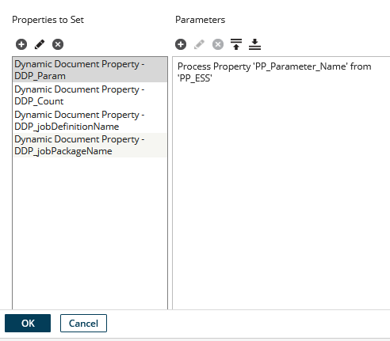

Demo process calls the sub process ‘submit ESS Job’ to get the response as a Job ID. Once we receive the Job ID as response from oracle SaaS then will pass the Job ID in request to ‘get status of the ESS job’ and get the status as a response from Oracle SaaS to Dell Boomi.

Sample screenshot of the processes,

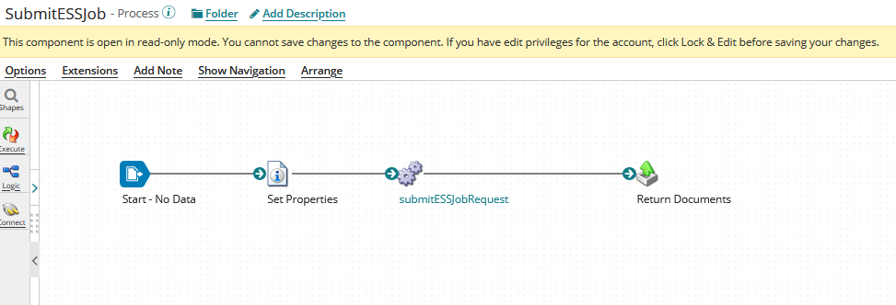

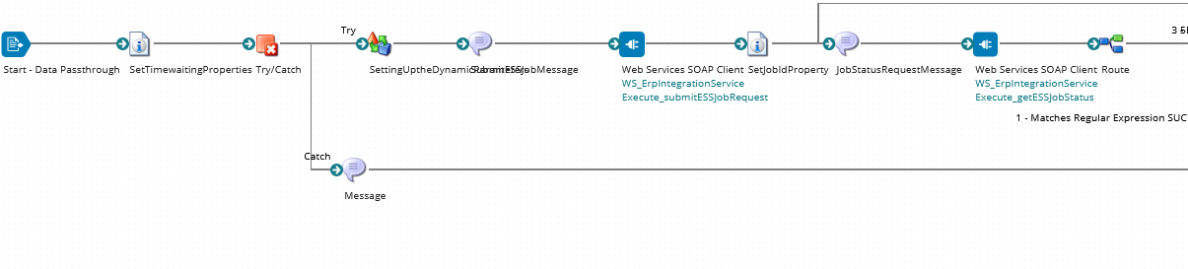

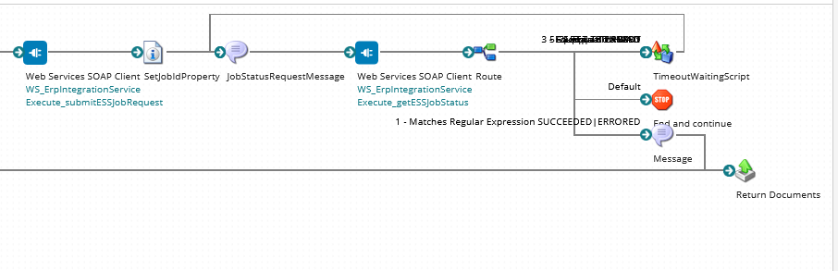

## **Testing**

In Testing, always we have considered positive and negative scenarios. here we demonstrated positive scenario test cases with a sample ESS job which has no parameters and the negative test scenarios with a sample ESS job which has parameters

### **Testcases without Parameters: (Positive scenario)**

Step 1: First will set the DDP_Count=0 so that parameter will set to 0 dynamically.

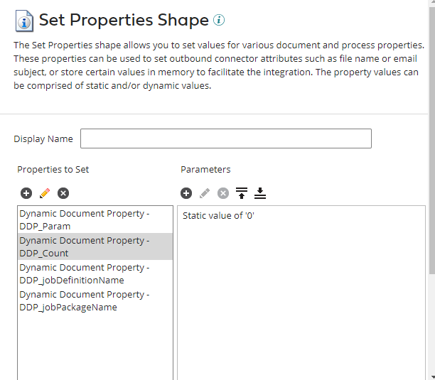

Step 2: Below is the request without parameter we are passing it to oracle submit ESS job.

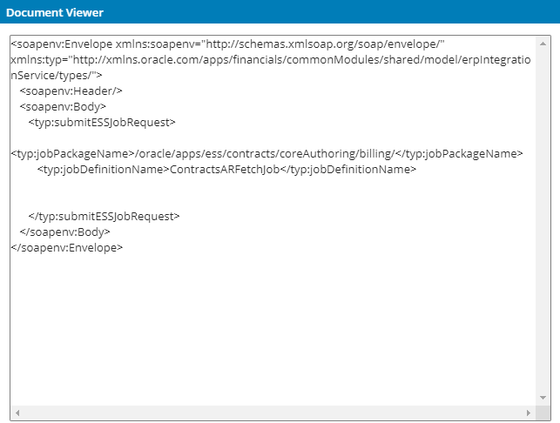

Step 3: Once the request is processed, we will get a response back from Oracle ESS with the job Id. Based on the job Id we receive from ESS, we will be sending a Job id to oracle to get the Job status and its completion.

**NOTE:** ESS job execution status can be viewed from Oracle SaaS at oracle instance with the help of oracle team/by having access, the same status we are getting back in boomi as a response to the request.

**Ready Status:**

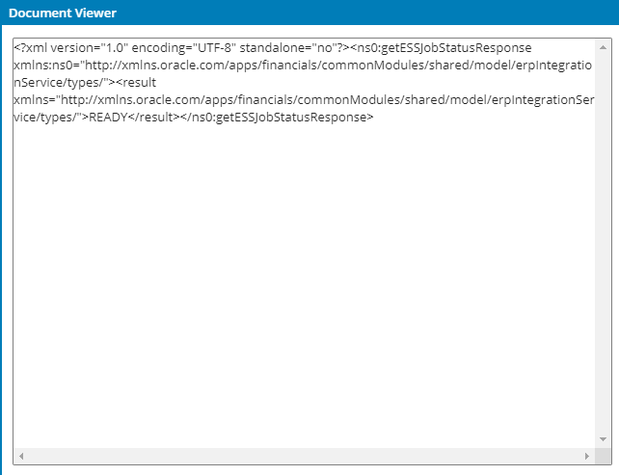

**Wait Status:**

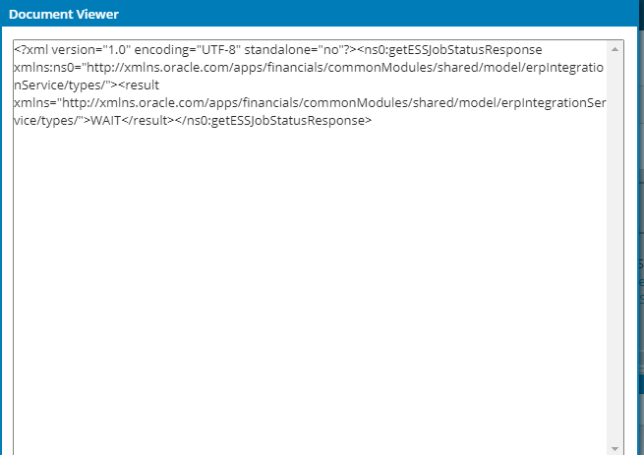

**Running Status:** 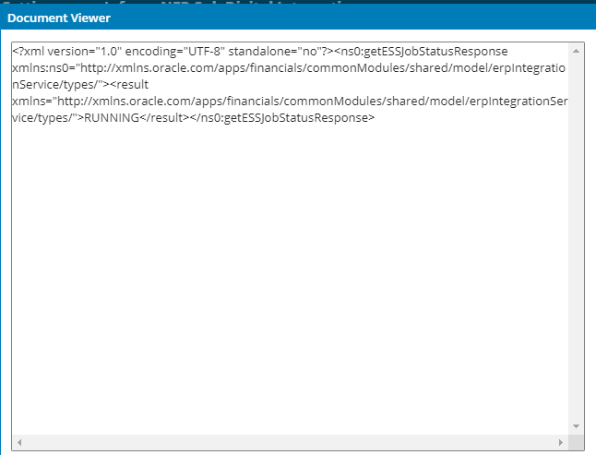

**Succeeded Status:**

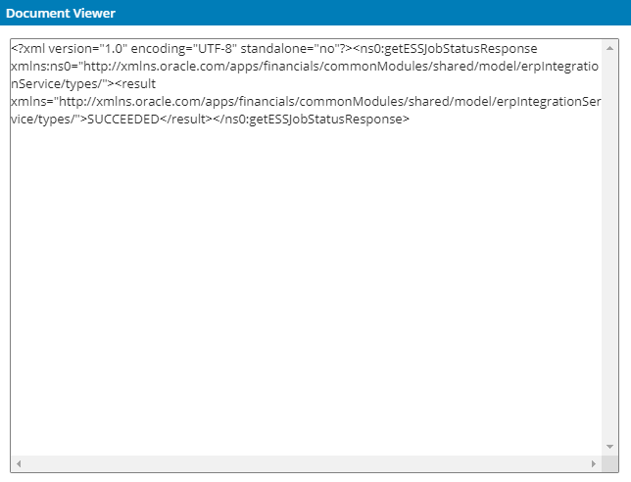

### **ESS Job-With Parameters List-Exceptional Handling: (Negative scenario)**

Below is the process flow for the ESS job with parameter check,

Here we passed all the 3 parameters based on the DDP count set as 3.

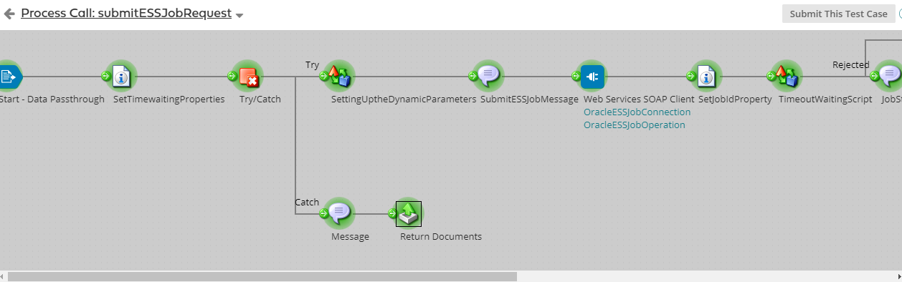

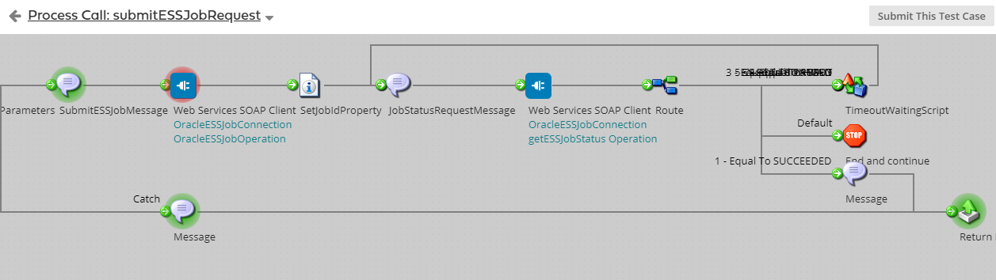

The process getting failed because job definition name which is passed here is doesn’t have access to the ESS job. Hence it is failed.

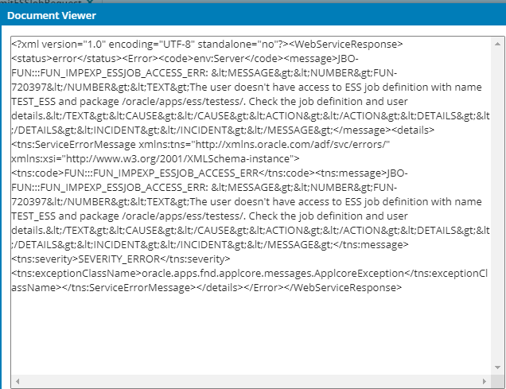

Below is the screenshot of catch response from ESS job.

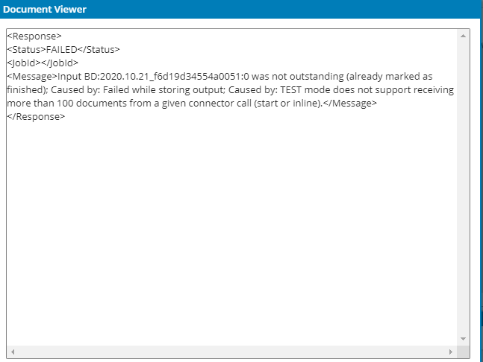

## **Sample Request and Response**

### **Profile Name: SubmitESSJobRequest**

**Description:** This is to send the request to oracle with parameter list along with job definition name and job package name.

**Sample Request:**

<soapenv:Envelope xmlns:soapenv="http://schemas.xmlsoap.org/soap/envelope/" xmlns:typ="http://xmlns.oracle.com/apps/financials/commonModules/shared/model/erpIntegrationService/types/">

<soapenv:Header/>

<soapenv:Body>

<typ:submitESSJobRequest>

<typ:jobPackageName></typ:jobPackageName>

<typ:jobDefinitionName> ContractsARFetchJob </typ:jobDefinitionName>

<!--Zero or more repetitions:-->

<typ:paramList>Param1</typ:paramList>

<typ:paramList>Param2</typ:paramList>

<typ:paramList>Param3</typ:paramList>

</typ:submitESSJobRequest>

</soapenv:Body>

</soapenv:Envelope>

### **Profile Name: SubmitESSJobRequestResponse**

**Description:**  This is the response which we are getting from oracle

**Sample Response:**

<?xml version="1.0" encoding="UTF-8" standalone="no"?>

<ns0:submitESSJobRequestResponse xmlns:ns0="http://xmlns.oracle.com/apps/financials/commonModules/shared/model/erpIntegrationService/types/">

<result xmlns="http://xmlns.oracle.com/apps/financials/commonModules/shared/model/erpIntegrationService/types/">2089069</result></ns0:submitESSJobRequestResponse>

### **Profile Name: getESSJobStatusRequest**

**Description:** This is to get the job status request based on the job ID from submit ESS job response.

**Sample request:**

<soapenv:Envelope xmlns:soapenv="http://schemas.xmlsoap.org/soap/envelope/" xmlns:typ="http://xmlns.oracle.com/apps/financials/commonModules/shared/model/erpIntegrationService/types/">

<soapenv:Header/>

<soapenv:Body>

<typ:getESSJobStatus>

<typ:requestId>2089069</typ:requestId>

</typ:getESSJobStatus>

</soapenv:Body>

</soapenv:Envelope>

### **Profile Name: getESSJobStatusResponse**

**Description:** This is to get the status of the ESS job. The status will be Ready, Wait,Error,Running,Completed,Succeeded.

**Sample Response:**

